Practical 8:- Performance Optimization and Lazy Loading in React
Objective: | To improve frontend performance using lazy loading and code splitting techniques.
Problem Statement: | • Optimize the React frontend of the Task Management application by implementing lazy loading for route-based components.  • Apply React.lazy() and Suspense to at least the Projects and Contact routes (or equivalent route-based components).  • Provide a meaningful fallback UI while a lazy-loaded chunk is loading.  • Measure and compare bundle size and load time before and after optimization using browser developer tools.  • Document the before/after comparison with screenshots or recorded values.
Implementation | LazyLoading Spinner :  import { Database } from 'lucide-react'  const Spinner = ({ label = 'Loading repositories…' }) => (  <div  role="status"  aria-live="polite"  className="surface-raised flex flex-col items-center justify-center gap-5 px-8 py-16"  >  <span className="relative inline-flex size-14">  <span className="absolute inset-0 animate-spin rounded-full border-[3px] border-line-strong border-t-bronze" />  <span className="absolute inset-1.5 flex items-center justify-center rounded-full bg-surface shadow-[inset_0_2px_5px_rgba(60,45,20,0.15)]">  <Database className="size-5 animate-pulse text-bronze" />  </span>  </span>  <p className="text-sm font-medium text-ink-soft">{label}</p>  <span className="sr-only">Loading</span>  </div>  )  export default Spinner  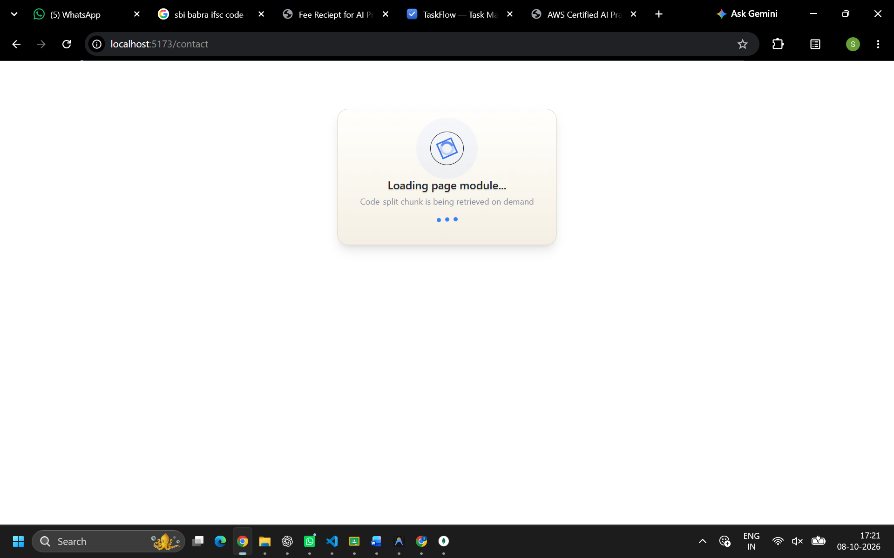
Outcome | Students will be able to apply code splitting and lazy loading in React to reduce initial bundle size, and will be able to measure and explain the resulting performance impact.

